**Lodging and Accommodations**

**Lodging is not reserved in blocks this year.** To allow for maximum options for attendees, you will need to choose a lodging option that meets your needs, but some lodging options include Oxford Suites, and Pendleton MotoLodge. Some accommodations have offered special rates, see below for details. See the map below for more choices. Note: There is a drawing to win accommodations for the conference when ordering meal and entertainment reservations below. So be sure to purchase a ticket for the raffle. The raffle will be drawn on May 4th, 2025, see link in   
"Meal and Entertainment Reservations" on this page to enter.

Click on any of these boxes to go directly to their websites:

*[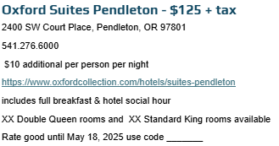](https://www.oxfordcollection.com/hotels/suites-pendleton)*

*[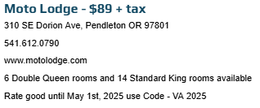](https://www.motolodge.com/)*

*[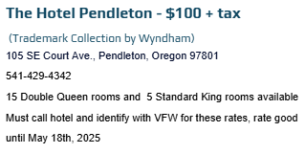](https://www.wyndhamhotels.com/trademark/pendleton-oregon/the-hotel-pendleton-trademark-collection/overview)*

*[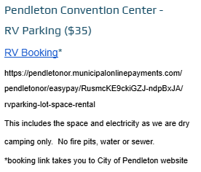](https://pendletonor.municipalonlinepayments.com/pendletonor/easypay/RusmcKE9ckiGZJ-ndpBxJA/rvparking-lot-space-rental)*

**Meal and Entertainment Reservation** *[LINK](https://www.zeffy.com/en-US/ticketing/2025-oregon-convention-final" \o "Convention-Meal-Tickets" \t "_blank)*.

**Order Your Meals Now!** Don't miss out – get your orders placed before **June 1, 2025**, to ensure you don't miss the cut-off! Secure your spot today and enjoy delicious meals at convention.

Options include:

*](https://www.zeffy.com/en-US/embed/ticketing/2025-oregon-convention-final?modal=true)*

* Thursday: Lunch
* Friday: Lunch -OR- "Over 40" (VFW years) Lunch
* Friday: Banquet Dinner
* Friday: Concert
* Saturday: Lunch -OR- Women Veterans Lunch
* May 4th: Accommodations Raffle

**Map with Local Locations of Interest:**

Black Stars: Convention Building Locations

Gold Pins: Points of Local Interest

Purple Beds: Lodging Options

Orange Mugs: Coffee

Orange Utensils: Local Food

Light Orange: Fast Food